Ohio Psychiatric Physicians Foundation
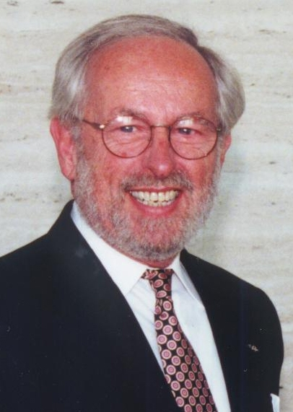

Philip A. Workman Memorial Fund

Philip A. Workman was hired by the Ohio Psychiatric Physicians Association in 1984 as its first full-time executive director. With Phil’s leadership, the OPPA was often held up as an example of an effective, respected district branch of the American Psychiatric Association. Phil served as a mentor to OPPA leaders, a collaborator with the medical and mental health communities in Ohio, and an effective director and manager of a statewide physicians’ specialty society for psychiatrists.

Phil was proud of the fact that he worked with 21 OPPA presidents between 1984 and when he retired in Jan. 2004. He was a founding member of the Fair Benefits Coalition in 1984, which became the Coalition for Healthy Communities (the statewide advocacy group that was instrumental in such accomplishments as passing mental health parity in 2006). Phil helped establish OPPAC, the Ohio Psychiatrists’ Political Action Committee, in 1986, providing a way for OPPA to educate legislators about issues of interest to its members. He also helped to establish the Ohio Psychiatric Association Education and Research Foundation (which later became the OPPF), with its charitable mission.

In January 2011, the Ohio Psychiatric Physicians Foundation established this fund in memory of Phil, who passed away in 2010. The purpose of this fund is to provide operational support for the Foundation as well as support for student internships and other educational opportunities in non-profit organization management.

Your tax-deductible contributions to this fund is a way you can honor the legacy of Philip A. Workman and his commitment to serving the needs of Ohio psychiatrists and the patients they treat.

