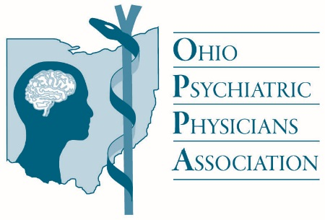
Congratulations to our
Life Fellows

Hareendra Adhvaryu, MD, Middleburg Heights
Gail Barker, MD, Cincinnati
David Berkowitz, MD, Cincinnati
Mohen Bohjwani, MD, Dayton
Homai Cupala, MD, Hinckley
Antoine Demosthene, MD, Lima
Panagiotis Doukides, MD, Toledo
Mark Frankel, MD, Cleveland
Fredrick Gensler, MD, Cincinnati
Alice Hale, MD, Columbus
Ock Hong, MD, Toledo
Ewald Horwath, MD, Cleveland
Pythias Jones, MD, Shaker Heights
Robert Karp, MD, Holland
Barbara LaForrest, MD, Holland
Douglas Moul, MD, Willoughby Hills
F. Gregory Noveske, MD, Westlake
Marilynn Peters, MD, Gahanna
Luis Ramirez, MD, Brecksville
Nukala Reddy, MD, Munroe Falls
Lee Shonfield, MD, Cincinnati
Sehba Siddiqi, MD, Dayton
Kuldip Singh, MD, Cincinnati
Cynthia Taylor, MD, Cleveland
Henry Waite, MD, Cincinnati
Lawson Wulsin, MD, Cincinnati
Denton Wyse, MD, Archbold

